Install Postgresql pass 12345…

Buat database klik new databases jenengi **kopral**

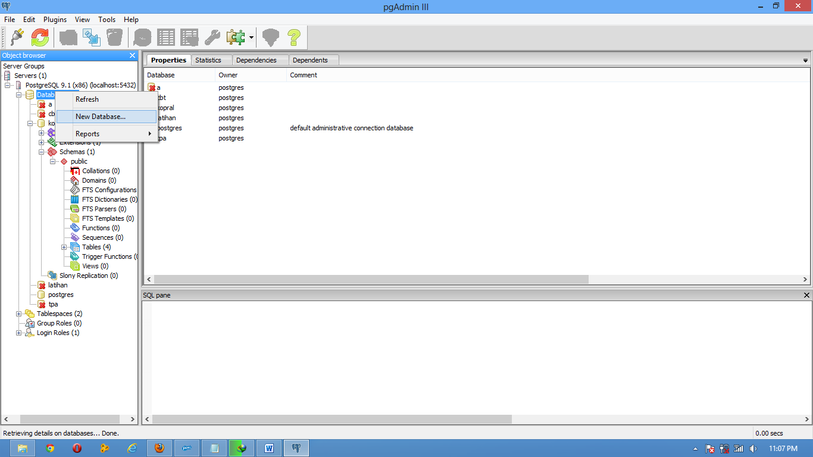

2. klik kopral terus pilih tombol SQL warna kuning di toolbar

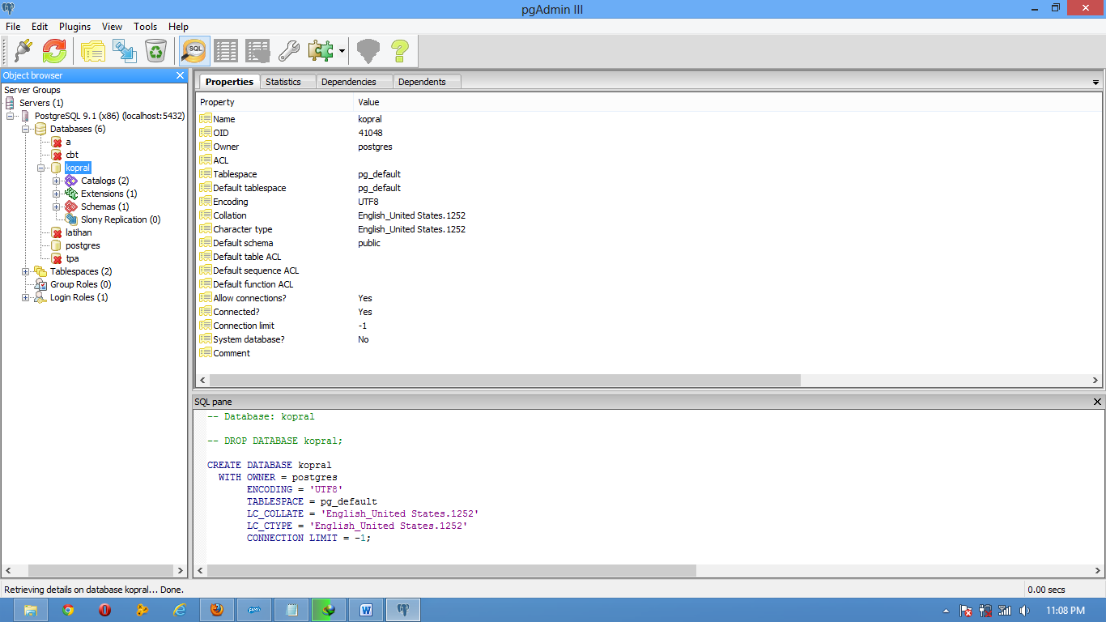

3. Copas Sql iki

**CREATE TABLE anggota**

**(**

**noktp character varying NOT NULL,**

**kelompokdesa character varying,**

**namalengkap character varying,**

**pinjaman bigint,**

**tglpinjaman date,**

**rt character varying,**

**rw character varying,**

**dusun character varying,**

**jabatan character varying,**

**nohp bigint,**

**CONSTRAINT anggota_pkey PRIMARY KEY (noktp )**

**)**

**CREATE TABLE desa**

**(**

**namadesa character varying NOT NULL,**

**kodedesa character varying,**

**CONSTRAINT desa_pkey PRIMARY KEY (namadesa )**

**)**

**CREATE TABLE kelompok**

**(**

**kodekelompok character varying NOT NULL,**

**namakelompok character varying,**

**namadesa character varying,**

**tangalberdiri date,**

**jumlahpinjaman bigint,**

**tanggalcairpinjaman date,**

**CONSTRAINT kelompok_pkey PRIMARY KEY (kodekelompok )**

**)**

**CREATE TABLE users**

**(**

**kode character varying NOT NULL,**

**nama character varying,**

**username character varying,**

**password character varying,**

**jabatan character varying,**

**CONSTRAINT user_pkey PRIMARY KEY (kode )**

**)**

4. Jalakno sql iku carane pilih pertable blok lansung tkn f5

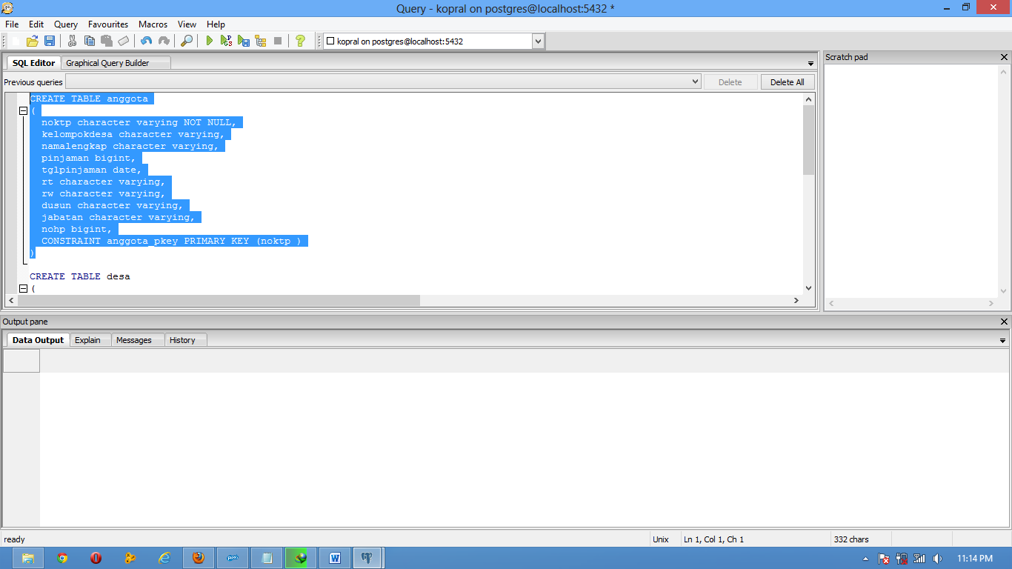

**Nek mari koyok kene**

